

**Leadership and Service – In School and Community**

Inscribed on our school seal, school rings and yearbooks – ingrained in our school spirit. Our Scholarship winners exemplify those qualities. They have distinguished themselves and bring pride and prestige to themselves, their families and their communities.

**Over $250,000 has been raised and awarded as scholarships since 1961**. Every year, without exception, scholarships have been awarded to deserving college bound students – initially to SHHS students and now to relatives of SHHS Alumni Association members. This year **another 15 $1,000.00 scholarships will be awarded in May**, as has been our practice for the past several years and fully expect to continue in the future.

Recently, Brian O’Neill, Post-Gazette, wrote, “What was it about this defunct school on the southern side of Mount Washington that keeps its graduates plunking down thousands of dollars each year for kids that probably couldn’t find the school if you stuck them on Grandview Avenue and handed them cab fare.” Good question … what is it about SHHS alumni?

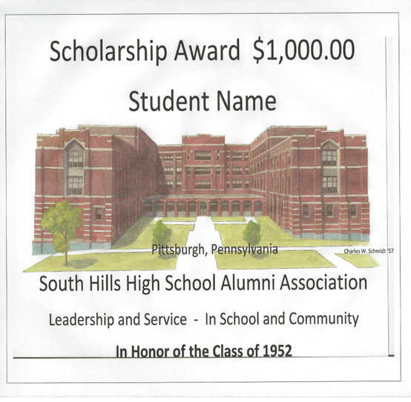

**Scholarship Donation**

**Any amount $$$$ - Large or Small**

**SHHSAA Scholarship Fund will use it all**

**100% of Scholarship Donations Go To Scholarships!**

Name ___________________________________________________________________________

Address __________________________________________________________________________

Telephone ________________________________________________________________________

Email ____________________________________________________________________________

Year Grad __________________ Donation Total ________________________________________

Donation In Honor of _______________________________________________________________

or In Memory of ___________________________________________________________________

or other request ___________________________________________________________________

If this is a full Value Scholarship Award of at least $1,000 you may designate the name of an award.

If your class has collectively contributed enough for a full value scholarship it can be designated

in Honor of Class of 19____ or In Memory of __. Other requests will be considered on an individual

case basis.

Make check payable to:

SHHSAA

PO Box 67

Bridgeville PA  15107